https://www.perutravelexpertsb.com/tours/inka-trail-4d

INCA TRAIL TO MACHU PICCHU 4 DAYS / 3 NIGHTS – PRIVATE SERVICE

Itinerary:
Pre-trek briefing for the Inca Trail Trek
You will have an in-depth briefing with your guide 1 or 2 days before your trek. Your guide will meet you at your hotel and you can take this opportunity to ask questions and make any final preparations.

Day 1: Cusco – Trailhead at Km 82 – Wayllabamba.
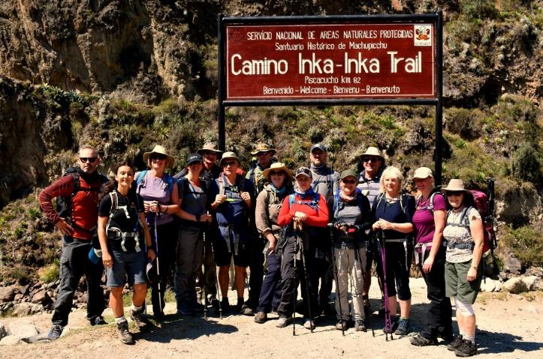
We will pick you up at your hotel in Cusco at 5:20 AM! The ride to the trailhead at Kilometer 82 is beautiful.
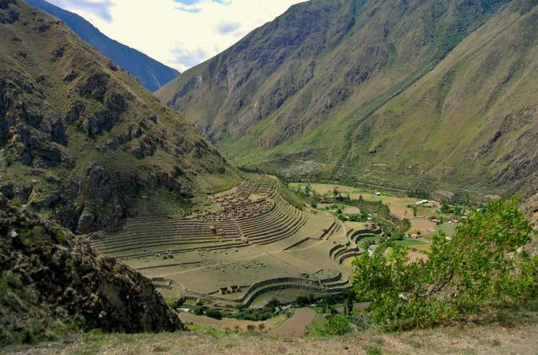
This drive will be 1 hour and 45 minutes approximately to reach the town of Ollantaytambo. This town is an excellent spot to get breakfast and buy any last-minute supplies prior to arriving at the trailhead. After your break in Ollantaytambo. You will then get back in the van to travel the final 40 minutes to reach the trailhead at Kilometer 82. At this point you will go through the Inca trail checkpoint to show our original PASSPORT and start your Inca Trail hike.
The hike begins with 2 ½ hours of relatively flat terrain until you reach the Miskay Village where you will have a break, after that you start your first uphill trek to reach Wilkaraqay Inca site. From this location, you will have gorgeous views of the Llactapata (2,750 m/ 9,020 ft) archaeological site, which was a check point on the Inca trail approach to Machu Picchu. At this point we will go over the history of this site as well as have an overview of the history of the Inca trail.
Back on the trail, you will hike for 1 hours until we reach Tarayoq Village (2,598 m/8,525 ft) where you will have your lunch. This will be your first meal from your incredible chef and will give you an idea of the fantastic food you can look forward to the remainder of the trek!
After lunch, you will hike for 2 ½ hours until you reach your camp in Wayllabamba Village. Here your porters (angels) will offer you a hot bowl water to wash part of your body and relax until Tee time. You will have your first night on the Inca trail.
- Meals: Lunch/Dinner
- Accommodations: Camping
- Maximum altitude: 3,000 m/ 9,842 ft
- Minimum altitude: 2,750 m/ 9,020 ft
- Distance to walk: 10 km/ 6.2 miles
- Approximate walking time: 6 hours
- Difficulty: Moderate

Day 2: Wayllabamba – Dead Woman’s Pass – Pacaymayu.

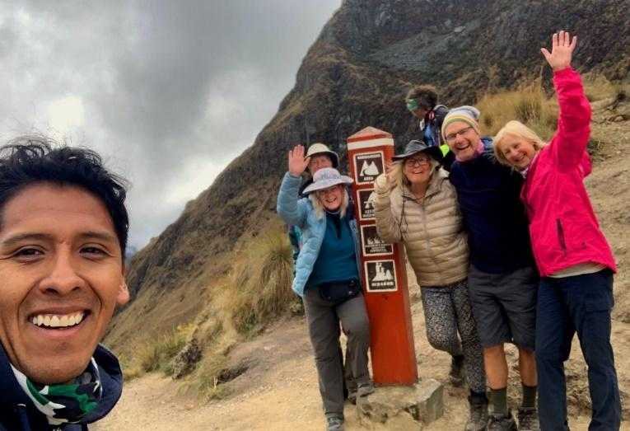
After a delicious breakfast, you will begin your hike to the famous Dead Woman’s Pass! 15 minutes after you left the campsite, you will cross the check point. Then you keep hiking uphill for 1 hours and 20 minutes to arrive to Ayapata break place where you will have some toilet. After your break here we continue and little by little you will be in the cloud forest. you will pass through various biozones including the low sierra and the high puna. There are many opportunities to see a variety of plant and birdlife and if you are lucky, you may also spot White-Tailed Deer.

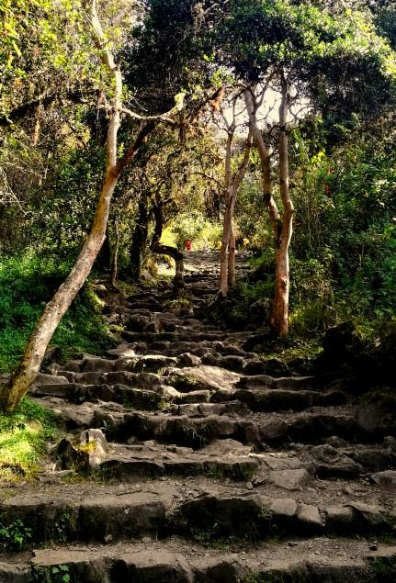

After this two-hour hike, you reach Llulluchapampa (3,800 m / 12,460 ft). This is a small camp and it is the absolute last location on the trail to buy supplies. Here will be your lunch spot. After your yummy lunch you will have a 15-minutes break then you will continue on the trail.
The portion of the trail leading to Dead Woman’s Pass at Warmiwañusca (4,215 m/ 13,825 ft) lasts two hours and takes you through beautiful mountains and the grasslands of the high Andes. You will pause at the top of this pass to admire the majesty of the highest point of the Inca trail.
You will then descend for around 2 more hours to arrive to the Pacaymayu camp where you will have your second camp.

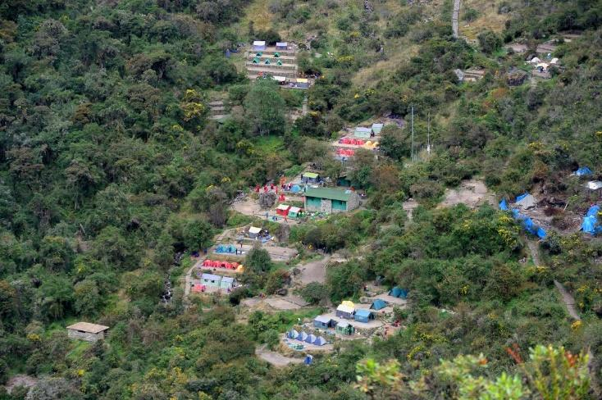
- Meals: Breakfast/Lunch/Dinner
- Accommodations: Camping
- Maximum altitude: 4,215 m/ 13,825 ft
- Minimum altitude: 3,000 m/ 10,824 ft
- Distance to walk: 10 km/ 6.2 miles
- Approximate walking time: 7-8 hours
- Area: the Andes and Cloud Forest
- Difficulty: Challenging.

Day 3: Pacaymayu – Phuyupatamarca – Wiñay Wayna.
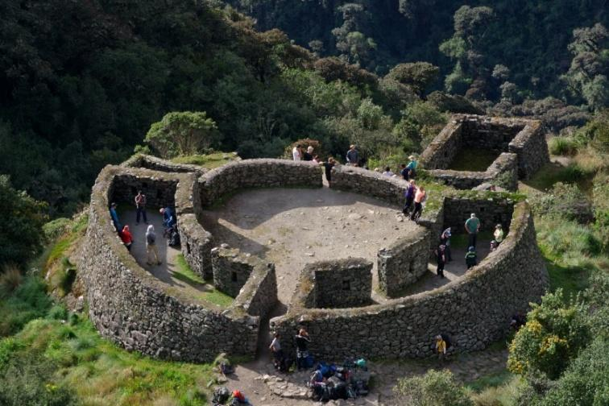
After another fantastic breakfast, you will ascend 45 minutes to the Inca site of Runcuraccay. Here you will have the explanation about this place and more and then you will continue uphill for an aditional hour to get the second high top Runcuraccay pass (3,950 m/ 12,959 ft).
Aftery our break on the top you start your descent of 90 minutes, you will arrive at the Inca site of Sayacmarca (3,657 m /12,000 ft). At this location you will have the chance to explore it.
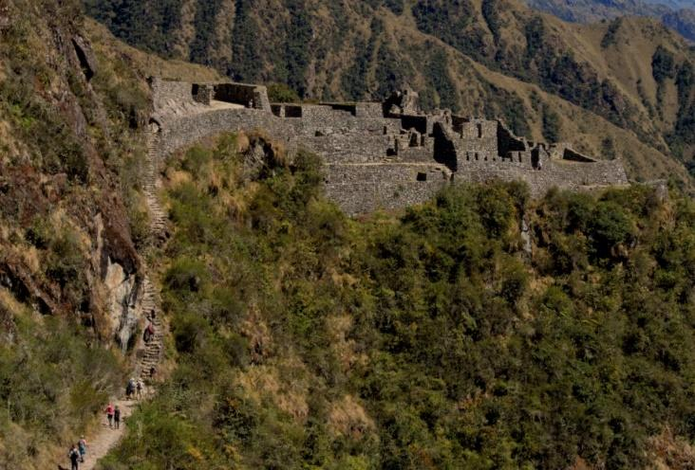
From here it is 25 minutes Chaquicocha (3,600 m/11,800 ft) which is a camp site for some groups and Lunch spot for others, for you will be just a break place. After your break you will hike for two hours until your lunch spot which is as well the most beautiful camps site for others groups, this place is at 3,680 m/ 12,073 ft named Puyupatamarca.

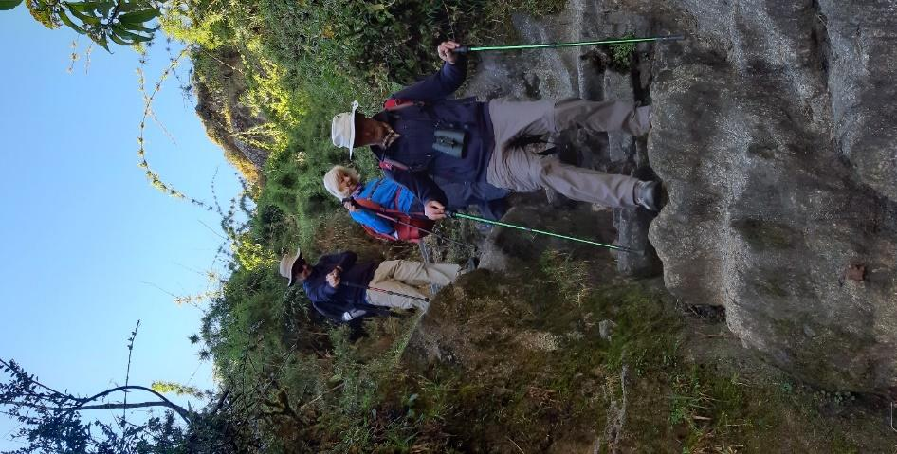
After your tasty lunch you will start to descend and you will visit Phuyupatamarca Inca site where your tour guide will give you all the information about this site. Afterwards is time to head into the rain forest! you will walk downhill for 2 ½ hours until you reach your camp. During this stretch of the trail, you will visit Inti Pata. Many people feel that the most beautiful pictures of the entire Inca trail can be taken from this location, After Inti Pata it is a further 30 minutes to Wiñay Wayna (2,680 m /8,792 ft) that will be your last Camps site.
Tonight, after your dinner you will say good bye to your porters in a small meeting. This will be the last chance to show your gratitude to them.
- Meals: Breakfast/Lunch/Dinner
- Accommodations: Camping
- Maximum altitude: 3,650 m/ 11,975 ft
- Minimum altitude: 2,680 m/ 8,792 ft
- Distance to walk: 16 km/ 9.94 miles
- Approximate walking time: 10 hours
- Area: High Cloud Forest
- Difficulty: Easy – Moderate.

Day 4: Wiñaywayna – Machupicchu - Aguas Calientes.

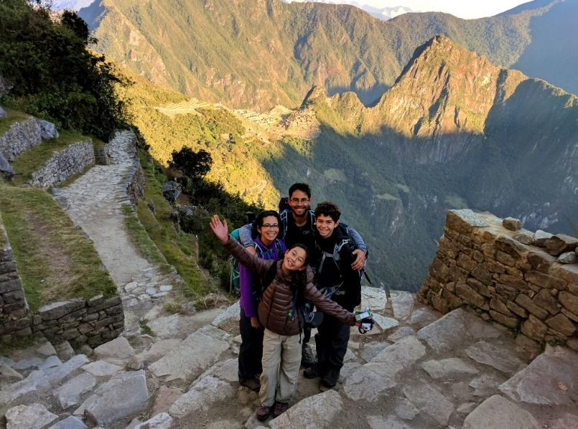
Today you will wake up around 3:30 am, Your Porters will wake you up with a coca tee in your tents with your box breakfast, then you will have 30 minutes to pack, ready and walk to the last check point of the Inca Trail.

The check points open at 5:30 am and you will make the final stretch of the Inca Trail, which brings you to Inti Punku or the Sun Gate, the principal entrance of the crystal city of Machu Picchu. The trail here is fairly easy going and after about an hour you will arrive at Inti Punku (2,400 m/ 7,875 ft), an awesome location to
observe the citadel of Machu Picchu. From Inti Punku it is a further 45-minutes downhill hike to the citadel of Machu Picchu. Once in, you will walk down to the check point of the citadel and get out. Outside you will have 30 minutes to use toilets and the cafeteria. If you have backpacks over 25 liters, we will need to store them before get back to Machu Picchu.

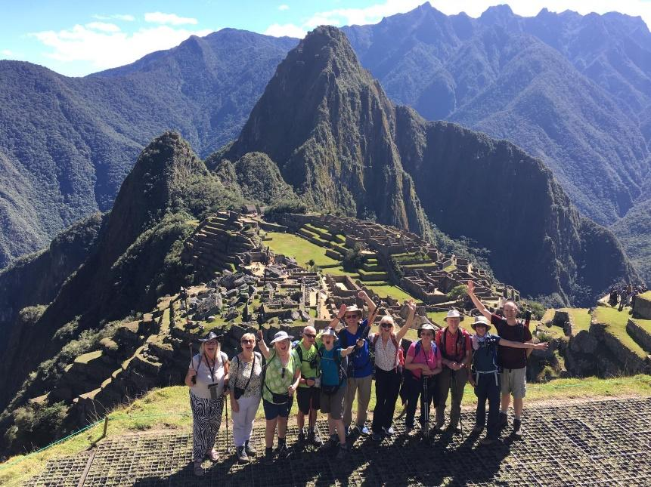
After your break outside you will need to show your original passport in the check point, then you will walk up for 15 minutes to get the classic “photo” spot and take all pictures you want. Afterwards your pictures you begin the tour, your tour here will last about 2 hours, where you will visit the most important places of the wonderful Inca city.
After your visit you take the bus down to Aguas Calientes town for lunch and then you will take the train back to Ollantaytambo and then private car back to Cusco city.

- Meals: Breakfast and Lunch
- Maximum altitude: 3,600 m/ 11,811 ft
- Minimum altitude: 2,000 m/ 6.561 ft
- Distance to walk: 13 km/ 8 miles
- Approximate walking time: 5 hours

Includes
- Trek briefing with your guide.
- Professional trek Guide
- Second tour guide for groups of 9+
- Private transport and professional driver (to the starting point of hike – km 82). All entrance tickets and permits for Inca Trail and Machu Picchu Park.
- Indigenous porters to carry camping equipment: client tents, dining and cooking tents, table, stools, cooking gear, stove, gas container, cutlery, plates, food and fresh vegetables.
- Bus ticket from Machu Picchu to Aguas Calientes Village.
- Machu Picchu guided tour (2 hrs.)
- 1 train ticket from Machu Picchu Pueblo to Ollantaytambo village (Expedition Tourist Train).
- Transport from Ollantaytambo Village to Cusco City.
- 3 nights camping “Inca Trail Trek” Spacious tents/Sleeping mat.
- Boiled water provided from the first day to the end of the trek (for drinking during the hike)
- One chef and assistant cook
- Excellent Meals: 2 Breakfasts, 1 Box breakfast, 3 Lunches, 3 Dinners
- Food includes pancakes, omelets, soups, fresh fruit, avocado, pasta, chicken, fish, meat, and rice, all rich in carbohydrates and suitable for trekking.
- (Vegetarian, vegan or special diet meals upon request.)
- Tea time before dinner (tea, coffee, biscuits and popcorn.)
- Wake up to coca tea in your tent.
- Buckets of hot water for washing in your tent every day
- Biodegradable soap and hand cleansing gel.
- Oxygen Tank & First aid kit
- All local taxes

Does Not Include
- Sleeping Bag (Can be hired from us)
- Breakfast on Day 1, lunch and dinner on Day 4.
- Entrance to Huayna Picchu Mountain $ 75.00
- Energy snacks. So, it would be useful to bring some such as chocolate bars and dried fruits.
- In an effort to reduce plastic waste on the trail we encourage our guests to use refillable water bottles
- **Tips for the crew (porters, chef and guide)

What you need to take
- A good day pack: such as Eagle Creek Afar Backpack (Appropriate pack to carry your personal belongings.)
- Original passport (International Student Identity Card “ISIC” if applicable)
- Travel insurance (strongly recommended but not required)
- Lighter trekking boots (with good ankle support)
- 3 pairs of trekking pants (not jeans), 1 hiking, 1 cotton–which is just enough.
Please spray both pairs with an insect repellent spray before the trip.
- Layers for variable temperatures especially at night
- 1 rain jacket: The first night the temperature can be as low as –5 degrees Celsius/23 degrees Fahrenheit. A rain jacket can be helpful because there are rainy days even in the dry season!
- 1 warm/winter jacket (Thermals: wool socks/gloves, scarf and woollen hat for cold nights).
- 5 pairs of underwear, 6 pairs of socks (Bamboo or cotton/nylon-blend socks dry faster than 100 per cent cotton, which lose their softness when air-dried.) It is nice to have a couple of extra pairs of socks to change into at night when you’re not hiking. Also, we recommend bringing both really heavy hiking socks and lighter socks, as well as the weather, is variable, so you want to make sure you’re not too cold or too hot.
- 5 shirts, 3 long sleeve shirts
- 1 good sleeping bag liner which is super lightweight and easy to pack.
This definitely does its job!
- Travel-size tissues and wet wipes–The air is cold and damp, so your nose is going to run a lot. Everyone seems to run out of tissues by the end of the trek. Also, most bathrooms do not have toilet paper (if you even get a bathroom), so wet wipes are key.
- Iron tablets and pills for altitude sickness. Several people on the hike have varying degrees of altitude sickness and both of these remedies (in addition to the coca tea) are very helpful in alleviating the symptoms.
- Sun protection cream (SPF 45 or higher recommended).
- Bug spray with 30% DEET in it–which you need, but it doesn’t work very well. The issue with Cusco outdoor is that most of the bugs are not mosquitoes. They are these small flies you can’t even see that leave weird bites that first look like you pricked your finger and then blow up into itchy red bumps. Unfortunately, these bugs seem to bite you no matter what kind of spray you put on, so bringing some anti-itch ointment could be helpful.
- Re-usable plastic or metal water container or a hydration pack such as Camelback
- Water (Only for the first day of the hike, as we will provide you with water throughout the rest of the hike).
- Camera and film
- A headlamp to navigate camp in the evenings and pre-dawn mornings with spare batteries
- Bandages or moleskin
- Flip flops to change into at night. Your toes will thank you!
- Toiletries: toothbrush, toothpaste/floss, shampoo/conditioner, Vaseline (great for potential blisters on the feet), feminine hygiene products, deodorant, nail clippers/file/tweezers, spare glasses and/or prescription, minieyeglass repair kit, contact lenses and supplies, hand sanitizer etc. Pack what you need, but pack light.
- Medication (Imodium AD or something for your stomach) because some people get an upset stomach on the trek. Also, Ibuprofen or Acetaminophen can be helpful to help with aches and pains after 8-10 hours of hiking each day.
- Plastic bags for dirty and wet clothes.
- Extra money for drinks
- Emergency money at least 400-500 extra soles (USD$ 160)
- **Tips (the amount you tip (or if you tip) is a personal decision and it is NOT mandatory.
Optional Extras (Need to Book in Advance):
- Machu Picchu Mountain climbing: USD 75.00 (Need to book in advance)
- Huayna Picchu Mountain climbing: USD 75.00 (Need to book in advance)

Rentals:
- Hiking poles (2 units) – US$15.00
- Sleeping bag (1 unit) – US$25.00
- Private Tent – US$30.00

We recommend to book Inka Trail at least 6 months in advance.
THE PRICE FOR PRIVATE INKA TRAIL 4 DAYS TOUR IS
1-2 PEOPLE | 3 PEOPLE | 4 PEOPLE | 5 PEOPLE | 6 PEOPLE | 7 PEOPLE | 8 PEOPLE
$ 2269 | $ 1999 | $ 1939 | $ 1729 | $ 1619 | $ 1559 | $ 1489

